
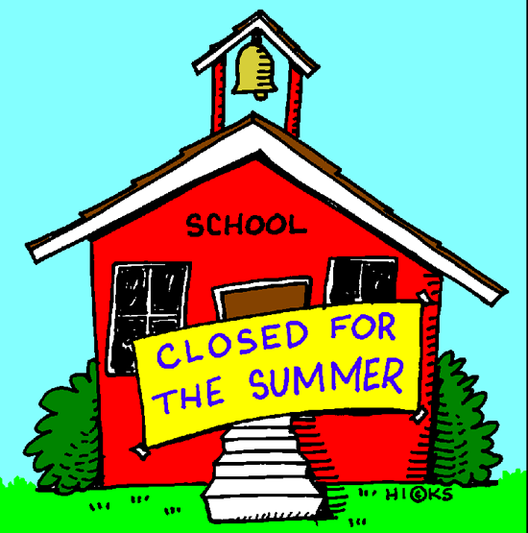
École Vickers
Public School
Principal – Dr. D. Sander
Vice-Principal – Mrs. C. Cey
Vice-Principal – Mme K. Cantin

Web address: https://vk.srsd119.ca
2800 Bradbury Drive
Prince Albert, SK
S6V 7K8
Phone 306-922-6446
Fax 306-764-1766

June 2017

24 HOUR ATTENDANCE NUMBER: 306-922-6446 or email/text address: vkattendance@srsd119.ca

Please Call, TEXT, OR EMAIL to Report all Absences
Monday | Tuesday | Wednesday | Thursday | Friday
 |  |  |   1  French Kindergarten Bowling and Firehall Visit P.M. | 2    Hot Lunch
5  P4A Track Meet  Prime Ministers Park | 6 | 7 | 8  Grade 7/8 Banff Band Trip | 9    Twin Day
12 | 13 | 14    Grade 3  Conservation  Learning Center  in the Morning | 15    Sports/Jersey Day    Gr. 3 Vintage Power Museum 9:30-2:00 | 16  PLC  No Classes
19 | 20    English Grades 1-3 Melfort Wave Pool | 21 | 22 | 23    Math Movie Premiere
  26  Mme N’s Kindergarten Celebration large gym    Gr. 4-8 Little Red River Park | 27  Ms. Fehr’s Kindergarten Celebration in classroom  Grade 8 Farewell large gym 6:30-10:30  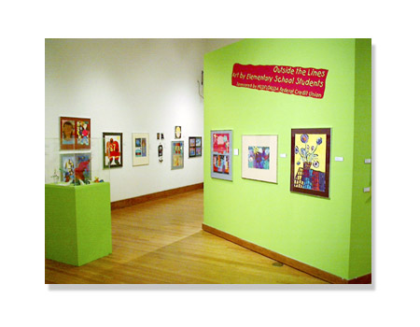  Gr. 2 French @ Mann Art Gallery 12:00-2:30 |   28  Gr. 3’s Galaxy Cinema  11:30-2:00 |   29  Last Day of School    Grade 8  to Batoche | 30

Please take note of our new email address, vkattendance@srsd119.ca, to inform the school of a student absence.

*Prices and availability are subject to change without notice*

Pizza: Pepperoni & Cheese $2.50/slice
(specialty pizza served on Fridays only)

Chicken Wraps $3.00

Sandwiches: Egg salad & Chicken salad $3.00

Salads: Taco, Caesar, Pasta, and veggies & dip $3.00
- Because they are perishable, wraps, sandwiches, and salads are ordered on Tuesdays and Thursdays in small quantities. Please have an alternate choice, as they are only available on a first come first serve basis.

Corn dogs $1.50

Pizza Pops/Mini Pizzas: Pepperoni and cheese $2.00

Breadsticks & cheese, granola bars & popcorn .50¢

Crispers $1.50

Individual packages of goldfish crackers $1.00

Cherry nibs .25¢

Flavoured water $1.50

White/Chocolate milk $1.25

Juice
boxes $1.25
cans: apple & orange $1.50

Desserts: 2 cookies, rice crispy square, wagon wheel, pudding (chocolate & vanilla), canned fruit (peaches & oranges), applesauce, frozen yogurt tubes $1.00

SEASONAL ITEMS MAY BE AVAILABLE FOR .50¢-$1.00
(i.e. Easter eggs)
**SENDING A NOTE WITH YOUNGER KIDS IS ALWAYS HELPFUL!


You can text in your attendance!!! Just enter vkattendance@srsd119.ca where you would normally add a phone number, create a message then send! Please always remember to let us know your student’s full name.


Important Information about 2017-2018 French Immersion Busing:
As part of Saskatchewan Rivers Public School Division’s commitment to French Immersion programming, Arthur Pechey will see the enrollment of grades 5-7 this fall.

Families living on the west side of 6th Avenue East are within the Arthur Pechey attendance area, while families on the east side of 6th Avenue East are a part of the École Vickers Public School area. A student’s enrollment for French Immersion is determined by the school attendance area in which they live. However, during this time, we offer cross boundary transportation as we recognize the change may present a hardship in regards to child care.

During the 2017-2018 school year, an evaluation will occur to determine whether to continue or discontinue the practice of cross boundary transportation.

Registering your child for busing is necessary, but not every year. Please only re-register if the student’s information is changing. This may include a change of school, address or contact information.

Registering online is quick and easy. Doing so now will ensure your child is placed on the proper bus for the first day of school. Not registering on time will result in delays in assigning your child a bus. It may take several days into the new school year to arrange their busing.

The direct link to register is https://www3.srsd119.ca/busgarage/transport/request.php or you can simply type “Sask rivers school bus” in a search engine (we recommend Google) and we will surely pop up. Once you click on our link, look for this box towards the bottom of the page, and choose “Transportation Requests”. You may find our links for the daily bus report and city bus maps handy as well.

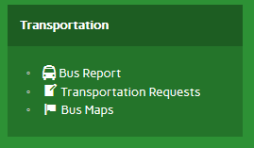

If you are unsure whether or not you have previously registered, or if you have any questions, please contact your school or the Transportation Department at 306-763-2323.

Thank you,

Ryan Bruce
Manager of Transportation


Grade Eight Farewell Celebration
The grade eight farewell celebration will occur on Monday, June 27 beginning at 6:30 pm in the large gym. Further information will be forthcoming.

Parents of Grade 8 Students:

The École Vickers Public School Community Council would like to provide $300.00 toward the sundae bar, snacks and decorations for the Grade 8 Farewell being held in the small gym.on June 27. The grade 8 parents organized this Last year. We are looking for one or more people/volunteers to organize and arrange this for the Grade 8 Farewell. If you are interested, please let Dr. Sander, Mrs. Cey or Mme Cantin know. Thank you!


Year-end report card distribution

Students will be given their June report card before leaving on the last day of school on Thursday, June 29, 2017. If you would rather the report card be mailed, please provide a large, stamped, self-addressed envelope to your homeroom teacher.

It has been an interesting year for the students, staff and community of École Vickers Public School. The French Immersion Program Enhancement study was conducted last year resulting in many kindergarten to grade four French Immersion students attending Arthur Pechey Public School this year. Next year, many kindergarten to grade seven French Immersion students will be attending Arthur Pechey Public School. This transition has been challenging for some and exciting for others.

École Vickers Public School is a very successful school with very successful students. The students are successful at academics in both English and French. Our Developmental Education Program is exemplary. Our students achieve great success in all extra-curricular activities. Our teams have been very competitive again this year and were extremely successful in sports and Physical Education. Equally, our bands, choir and hand bells groups continue to set a high standard for fine arts excellence.

The thread that so tightly binds the students and staff together and creates the nurturing “family atmosphere” at École Vickers Public School is the community. The School Community Council, the Before and After School Program, and the tremendous parental support all contribute to making École Vickers Public School a most wondrous place to learn and grow.

Merci pour une très bonne année! Bonne chance aux élèves qui quittent notre école pour aller à l’école secondaire ou à l’école Arthur Pechey, et bienvenue aux élèves qui vont nous rejoindre à la maternelle l’année prochaine.

Thank you for a very successful year. Good luck to the students who are leaving Vickers to attend high school or Arthur Pechey next year, and welcome to the new students who will be joining us in kindergarten.

Darcy Sander
Principal
HAVE A PEACEFUL SUMMER!


Student placement
Student placement is determined by the staff of École Vickers Public School. Your child will know what class they have been placed in on the first day of school, which is Tuesday, September 5, 2017.


Just a reminder to all Vickers’ families to please phone 306-922-6446 or text/email vkattendance@srsd119.ca all absences in to the office. This will eliminate unnecessary phone calls home.

