
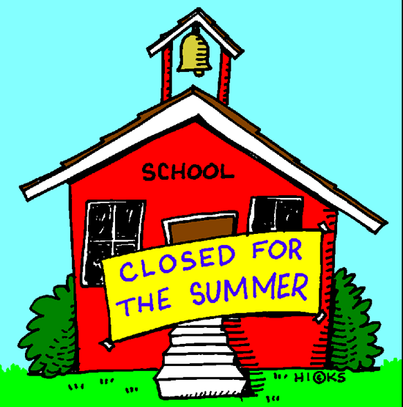
École Vickers
Public School
Principal – Dr. D. Sander
Vice-Principal – Mrs. C. Cey
Vice-Principal – Mme K. Cantin

Web address: www.srsd119.ca/vk/
2800 Bradbury Drive
Prince Albert, SK
S6V 7K8
Phone 306-922-6446
Fax 306-764-1766

June 2015

24 HOUR ATTENDANCE NUMBER: 306-922-6446 or email/text address: VKattendance@srsd119.ca

Please Call, TEXT, OR EMAIL to Report all Absences
Monday | Tuesday | Wednesday | Thursday | Friday
1  P4A Track Meet   U s e d B o o k S a l e  | 2 | 3 | 4 | 5  Mme Clifford Country Fun Farm
8  Mme N Country Fun Farm | 9 | 10  K-4 Playday | 11 | 12  PLC  No Classes
15 | 16  Grade 3 French Conservation Learning Center-Morning | 17  French grades 1-3  Melfort Wave Pool | 18  Mme N’s Kindergarten Farewell 11:00-1:00  large gym | 19  Mme Baranga: Anglin Lake  Mme Clifford’s Kindergarten Farewell 11:00-1:00 large gym
22  Ms St. Amand’s Kindergarten Farewell 11:00-2:00 large gym  All Grade 3s Galaxy Cinema-10:45-1:45  Grade 8 Farewell 6:30-10:30 large gym | 23  Grades 4-8 Galaxy Cinema | 24  English Grades 1-5  Melfort Wave Pool | 25  Grades 6-8  Melfort Wave Pool  Report Cards sent Home  Last Day of School | 26

Please take note of our new email address, VKattendance@srsd119.ca, to inform the school of a student absence.


Important information about SRPSD transportation

Any and all English and French Immersion students needing the school bus this fall must be registered.

They must register whether they are new to the bus or have been riding for several years. They must register whether they are a rural student or urban and regardless of what program they are enrolled in. They must register if they take a French Immersion bus or the “walk-to” bus. Any student needing school bus transportation must be registered for busing. Please note: Each French Immersion student living outside the Vickers’ area is allowed only ONE pick-up (morning) and ONE drop-off spot (afterschool). The morning pick-up can be different from the afterschool drop-off.

How and when do you register?

Registering online is quick and easy. Doing so now will ensure your child is placed on the proper bus for the first day of school. Not registering on time will result in delays in having your child assigned a bus. It may take several days into the new school year to arrange their busing.
The direct link to register is https://www3.srsd119.ca/busgarage/transport/request.php OR you can simply type “Sask rivers school bus” in a search engine (we recommend Google) and we will surely pop up OR you can go to www.srsd119.ca and click on the school bus icon located in the left bottom corner.

If you have any questions please contact your school or the Transportation
Department- 306 763-2323

Thank you,

Ryan Bruce Manager of Transportation

NEW!!!! Canteen Menu

*Prices and availability are subject to change without notice*

Pizza: Pepperoni & Cheese $2.50/slice
(Hawaiian and all meat served on Fridays only)

Chicken Wraps $3.00

Sandwiches: Egg salad & Chicken salad $3.00

Salads: Taco, Caesar, Pasta, and veggies & dip $3.00
- Because they are perishable, wraps, sandwiches, and salads are ordered on Mondays and Wednesdays in small quantities. Please have an alternate choice, as they are only available on a first come first serve basis.

Corn dogs $1.50

Pizza Pops/Mini Pizzas: Pepperoni and cheese $2.00

Breadsticks & cheese, granola bars & popcorn .50¢

Crispers $1.50

Individual packages of goldfish crackers $1.00

Cherry nibs .25¢

Flavoured water $1.50

White/Chocolate milk $1.25

Juice
boxes $1.25
cans: apple & orange $1.50

Desserts: 2 cookies, rice crispy square, wagon wheel, pudding (chocolate & vanilla), canned fruit (peaches & oranges), applesauce, frozen yogurt tubes $1.00

SEASONAL ITEMS MAY BE AVAILABLE FOR .50¢-$1.00 (i.e. Easter eggs)
**SENDING A NOTE WITH YOUNGER KIDS IS ALWAYS HELPFUL!



You can now text in your attendance!!! Just enter vkattendance@srsd119.ca where you would normally add a phone number, create a message then send! Please always remember to let us know your students full name.

Kindergarten registration for the 2015/2016 school year: We are now accepting registrations for both the English and French Immersion kindergarten classes. Please contact us at 306-922-6446 for further information.


SRPSD Proudly Announces New Websites…that showcase our commitment to student achievement and reflect the culture of excellence in our schools!
Saskatchewan Rivers Public School Division recently implemented newly designed webpages for our schools. Features of our new mobile friendly sites include standard quick links to bus updates and contact information, current handbook, newsletters, staff lists and familiar icons for quick recognition. We now have social media feeds displayed, and the ability to sign up to receive Google calendar updates or receive news via email. Please check it out at the same location as always, https://xx.srsd119.ca.

Cameras on School Buses

Saskatchewan Rivers Public School Division believes the use of video cameras on school buses enhances the safe operation of its school buses. Video cameras will enable school bus drivers to focus on the safe operation of the bus while improving student passenger identification procedures for disciplinary, medical emergency, and other related purposes. School buses servicing your school may be equipped with a video camera for these purposes. The full Video Cameras on School Buses Administrative Procedure 559 can be found on our website, www.srsd119.ca.



Just a reminder to all Vickers’ families to please phone 306-922-6446 or text/email VKattendance@srsd119.ca all absences in to the office. This will eliminate unnecessary phone calls home.

École Vickers Public School is a very successful school with very successful students. The students are successful at academics in both English and French. They achieve great success in all extra-curricular activities. Considering the multitude of banners hanging in the gym and the high athletic participation numbers, it is evident that the students are extremely successful in sports and Physical Education. Equally, our bands, choir and hand bells groups continue to set a high standard for fine arts excellence.
The thread that so tightly binds the students and staff together and creates the nurturing “family atmosphere” at École Vickers Public School is the community. The School Community Council, the Before and After School Program, the Jardin D’Amis preschool, the French Immersion Parent Advisory Council and the tremendous parental support all contribute to making École Vickers Public School a most wondrous place to learn and grow.
Merci pour une très bonne année! Bonne chance aux élèves qui quittent notre école pour aller à l’école secondaire, et bienvenue aux élèves qui vont nous rejoindre à la maternelle l’année prochaine.
Good luck to the students who are attending high school next year, and welcome to the new students who will be joining us in kindergarten.

Darcy Sander
Principal


Year-end report card distribution
Students will be given their June report card before leaving on the last day of school which is Thursday, June 25, 2015. If you wish that the report card be mailed to you, please provide a large stamped, self-addressed envelope to your home room teacher.


Student placement
Student placement is determined by the staff of École Vickers Public School. Your child will know what class they have been placed in on the first day of school, which is Tuesday, September 1st, 2015.

Grade 8 Awards
The recipients of Grade 8 Awards will be notified of their achievement via letter sent to the home.

HAVE A PEACEFUL SUMMER!

