

École Vickers
Public School
Principal – Dr. D. Sander
Vice-Principal – Mrs. C. Cey
Vice-Principal – Mrs. K. Cantin

Web address: www.srsd119.ca/vk/
2800 Bradbury Drive
Prince Albert, SK
S6V 7K8
Phone 306-922-6446
Fax 306-764-1766

February 2015

24 HOUR ATTENDANCE NUMBER: 306-922-6446 or email/text address: VKattendance@srsd119.ca

Please Call, TEXT, OR EMAIL to Report all Absences
Monday | Tuesday | Wednesday | Thursday | Friday
2 | 3 | 4 | 5 | 6  Interim Reports    HAT DAY
9 | 10  Grade 7  Try a Trade | 11 |   12  6:30 to 8:30  Grades 5-8 | 13  HAT DAY
16  No | 17  School: | 18  Winter | 19  Break | 20  ☺☺☺☺☺☺☺
23  Staff | 24  Appreciation |   25  Hot Lunch  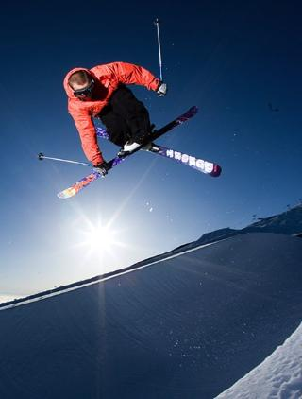  Grades 6-8  Ski Trip | 26  Week | 27  HAT DAY

Please take note of our new email address, VKattendance@srsd119.ca, to inform the school of a student absence.

Canteen Menu

*Prices and availability are subject to change without notice*

Pizza: Pepperoni & Cheese $2.00/slice
(as well as Hawaiian and all meat on Fridays only)

Wraps: Turkey or Chicken $3.00

Salads: Taco, Caesar, Pasta, fruit, and veggies & dip $3.00

Corn dogs $1.50

Pizza Pops: Pepperoni & bacon, or 3 cheese $2.00

Crackers & cheese snacks .50¢

Granola bars .50¢

Crispers: Bbq, salt & vinegar, all dressed, and ranch $1.50

Chocolate bars: Aero, Kit Kat, Caramilk, and Mars $1.50

Fruit by the foot $1.00

Popcorn .50¢

Nibs .25¢

Canned drinks: (Sparkling fruit juices, iced tea, etc.) $1.50

Flavoured water $1.50

Chocolate milk $1.00

Juice boxes: (Apple, orange, and fruit punch) .50¢



You can now text in your attendance!!! Just enter vkattendance@srsd119.ca where you would normally add a phone number, create a message then send! Please always remember to let us know your students full name.

Fifth Annual Le Jardin D’Amis Preschool Mom to Mom Sale is being held March 21, 2015 from 10am-3pm at the École Vickers School Gym. We are now booking garage sale tables ($35.00) for those selling their children’s gently used clothing, toys or books; and vendor tables ($50.00) for those selling products meant for mothers and families.
Contact Holly Osecki at 306-929-2529 or hollyosecki@hotmail.com to obtain a registration form.
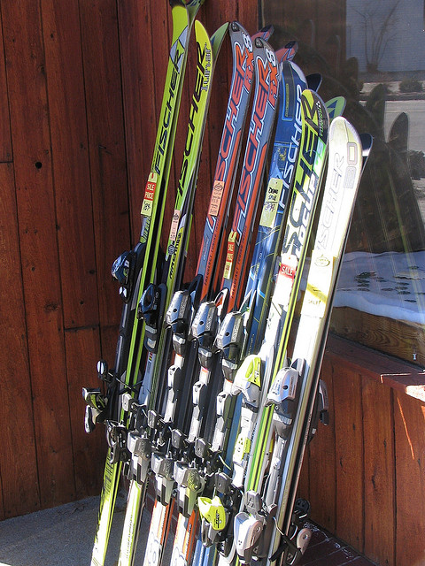
Grade 6 - 8 ski trip to Wapiti, February 25: departure is 7:30 am and return to school is 5:00 pm.

Kindergarten registration for the 2015/2016 school year: We are now accepting registrations for both the English and French Immersion kindergarten classes. Please contact us at 306-922-6446 for further information.


Busing News
Now that we are feeling the winter weather, we would like to make sure all parents are aware of our Cold/Inclement Weather Procedures. These procedures are in effect for both rural and urban bus routes.

The Transportation Office has two methods of communicating bus delays and cancellations:
- CKBI and CJVR radio stations receive all notifications. These stations will announce a list of delayed and cancelled buses.
- Notifications will be placed on our website, www.srsd119.ca.
We do not phone individual homes to report bus cancellations. We ask that you do not call the Transportation Office as they will be very busy managing the routes and ensuring the safety of the children on the buses.

Also, a reminder that food, including candy/suckers, and drinks and hockey sticks are not allowed on the busses. Injuries can occur. Secondly, skates must be transported in a closed or zippered bag.

Dress for the season:

Students must dress appropriately for the weather. They must be dressed adequately for a 1 kilometre walk in case of an emergency. Our bus drivers have the authority to warn/educate students on a first offense, and refuse transportation on the second. Saskatchewan Rivers Board Policies, Administrative Procedures and Transportation Manual can be reviewed on our website, www.srsd119.ca.


INCLEMENT WEATHER
For the most part, we want our students to enjoy playing outdoors before school, during both recesses, and the noon hour. On rainy days, we allow students to come into the school upon their arrival and remain indoors during all breaks. In the winter, we use -30 degrees Celsius as our cut-off to remain indoors. If the temperature, and/or wind chill in combination with the temperature exceed -30, then all students are permitted in the school in the morning and during break times. We do expect that all students be dressed appropriately for the weather, as there are many cold days that students are expected to be outdoors.


Cameras on School Buses
Saskatchewan Rivers Public School Division believes the use of video cameras on school buses enhances the safe operation of its school buses. Video cameras will enable school bus drivers to focus on the safe operation of the bus while improving student passenger identification procedures for disciplinary, medical emergency, and other related purposes. School buses servicing your school may be equipped with a video camera for these purposes. The full Video Cameras on School Buses Administrative Procedure 559 can be found on our website, www.srsd119.ca.

SLC EVENTS: All Fridays in February will be hat days. Students may bring $1 to wear their hats in class. We will also be selling Helping Hands the last week of February at first recess. The money raised from both events will go to Telemiracle. There will also be a dance on February 12 from 6:30 to 8:30 for Grades 5 - 8. Admission will be $1.


FRENCH IMMERSION NEWS:
Canadian Parents for French - Prince Albert Chapter invites members to a fun filled day at the Mini Micro Rendezvous on Saturday, February 7, 9:00am to 3:00pm at École Holy Cross. Cost is only $20 per child or FREE with a new/renewed three year membership!

Each French Immersion school in Prince Albert takes turns hosting this event. It is open to all pre-school (children must be entering Kindergarten in the Fall) to grade 5 Prince Albert and area French Immersion students.

Parents, please check your child’s communication folder, agenda, or backpack this week for the registration forms, OR check out the welcome page of our school website https://vk.srsd119.ca to download a registration form.

CPF members, check your email for registration forms or find them on Facebook at Canadian Parents for French - Saskatchewan!


Just a reminder to all Vickers’ families to please phone 306-922-6446 or text, email VKattendance@srsd119.ca all absences in to the office. This will eliminate unnecessary phone calls home.

We’re all in the same boat. Sailing toward numeracy!
Did you hate math as a kid??? The following article may provide some insight as to the importance of modeling a positive attitude toward math for your children as well as tips on how to support our school math goat at home.

http://www.pbs.org/parents/education/math/math-tips-for-parents/instill-a-love-of-math/

Win! Win! Win! Win!
Want a chance to win a gift certificate to the canteen and improve your numerical literacy? Simply print the math Bingo sheet or pick one up at the office, complete the activities on it, and enter it in the draw at the office. 2 draws will be made at the end of the month!

M | A | T | H
Bake something with your family. | Pay for something at the store. Did you get the right change? | Play a card game like Uno, Go Fish or Multiplication War. | Count the number of red cars, trees on the street, players on the team, etc.
Talk to your family about what you are learning in Math class. | Play a dice game like Yahtzee, Pig, etc. | Play license plate Math. Who can find the biggest number? What number is in the tens place?, etc. | Plan a meal using the flyers. Use a calculator to figure out the cost.
Find a number in the newspaper, a book or magazine. | Estimate how many toys are on the floor, books on the shelf, forks in the drawer, etc. | Make a Math question for someone else in your family to solve. | Ask your parents how they use Math at their job.
Estimate the cost of the groceries on your shopping list. | Practise Math facts in the car. | Check out the Vickers’ Math Pinterest Board. | Play a Math game online.
Name
Grade
Teacher
Parent Signature

