

École Vickers
Public School
Principal – Dr. D. Sander
Vice-Principal – Mrs. C. Cey
Vice-Principal – Mme K. Cantin

Web address: https://vk.srsd119.ca
2800 Bradbury Drive
Prince Albert, SK
S6V 7K8
Phone 306-922-6446
Fax 306-764-1766

December 2016

24 HOUR ATTENDANCE NUMBER: 306-922-6446 or email/text address: vkattendance@srsd119.ca

Please Call, TEXT, OR EMAIL to Report all Absences
Monday | Tuesday | Wednesday | Thursday | Friday
 |  |  | 1    Watsonairs  Carol Festival 7:00  Wesley United  Church | 2
5 | 6 | 7 | 8 | 9
12 | 13    Band, Choir & Hand bells Concert @ Rawlinson Centre 7:00 | 14  K-4 Christmas Concert @    Rawlinson Centre 12:30 and 7:00 | 15 | 16  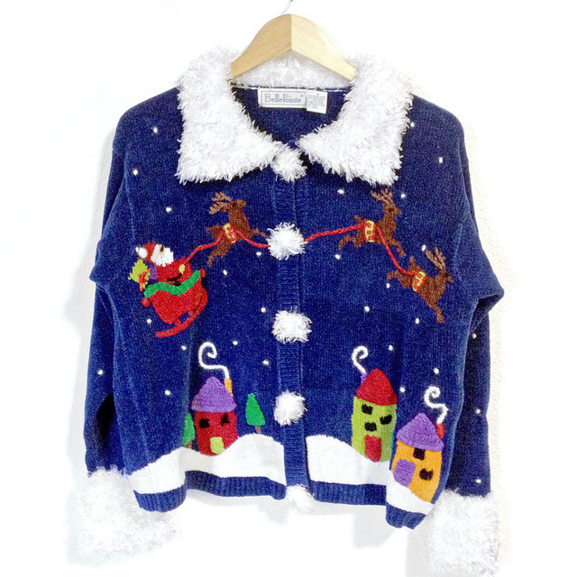  Red and Green/Christmas Sweater Day
19 | 20 |   21  PJ Day | 22  NO SCHOOL | 23
26  NO SCHOOL | 27 | 28 | 29 | 30  Return to School  January 3, 2017

Please take note of our new email address, vkattendance@srsd119.ca, to inform the school of a student absence.

Canteen Menu

*Prices and availability are subject to change without notice*

Pizza: Pepperoni & Cheese $2.50/slice
(specialty pizza served on Fridays only)

Chicken Wraps $3.00

Sandwiches: Egg salad & Chicken salad $3.00

Salads: Taco, Caesar, Pasta, and veggies & dip $3.00
- Because they are perishable, wraps, sandwiches, and salads are ordered on Tuesdays and Thursdays in small quantities. Please have an alternate choice, as they are only available on a first come first serve basis.

Corn dogs $1.50

Pizza Pops/Mini Pizzas: Pepperoni and cheese $2.00

Breadsticks & cheese, granola bars & popcorn .50¢

Crispers $1.50

Individual packages of goldfish crackers $1.00

Cherry nibs .25¢

Flavoured water $1.50

White/Chocolate milk $1.25

Juice
boxes $1.25
cans: apple & orange $1.50

Desserts: 2 cookies, rice crispy square, wagon wheel, pudding (chocolate & vanilla), canned fruit (peaches & oranges), applesauce, frozen yogurt tubes $1.00

SEASONAL ITEMS MAY BE AVAILABLE FOR .50¢-$1.00 (i.e. Easter eggs)
**SENDING A NOTE WITH YOUNGER KIDS IS ALWAYS HELPFUL!



You can now text in your attendance!!! Just enter vkattendance@srsd119.ca where you would normally add a phone number, create a message then send! Please always remember to let us know your students full name.
Library News

Thank you to the students, families and community members who supported the Fall Scholastic Book Fair. The selection of titles and number of books available was exciting to see. Our sales expectations were generously met and the library plans to use the credit to add more great titles to the collection. Watch for these new selections which will be available soon!

Congratulations to Ashton Tait & Max Obrigavitch and their classroom teachers, Mrs. Hayunga & Mme Desloges, who were the winners of the Book Fair draw. Each student picked $25 worth of books to take home and their teachers added the same amount of books to the classroom collection. Happy Reading!

Dec. 16th: Red and Green/Christmas Sweater Day
Dec. 21st: PJ Day!
The SLC will also be selling hot chocolate during the first and noon recesses for $1. There will be small candy canes or marshmallows with the hot chocolate.

WATSONAIRS CAROL FESTIVAL
  - On Thursday, December 1, students arrive at Wesley United Church at 6:30pm wearing their black and white dress clothes and choir vest.
  - Performance begins at 7:00pm.
  - Concert has a free will offering to go to the Salvation Army Christmas Cheer Fund.

Band/Choir/Handbells Christmas Concert
The annual concert will be held at the E.A. Rawlinson Centre on Tuesday, December 13, 2016 at 7:00 p.m. Students are asked to be at the Centre by 6:30 p.m. There is no admission charged, although a voluntary monetary collection will be available to help offset the associated costs.


Kindergarten to Grade Four CHRISTMAS CONCERT INFORMATION
This year, the annual École Vickers Public School Christmas Concert is on Wednesday, December 14th. The concert will be held at the beautiful E.A. Rawlinson Centre for the Arts. We will hold two performances. The first one is at 12:30 p.m. and the second at 7:00 p.m. We will provide bussing for the students to and from the afternoon performance and request that parents provide transportation to and from the evening show. Please have your child/ren at the Rawlinson Centre by 6:30 p.m. for the evening show. Doors open at 12:00 p.m. for the afternoon performance.

The maximum audience size per performance is 600, so we will sell tickets at the school starting on Wednesday, November 30th through your child’s homeroom teacher for $2.00 per ticket. Each family will be allowed to purchase 2 tickets for the afternoon performance and 2 tickets for the evening performance. The proceeds will be used to offset the rental costs of the facility and the bussing of the students for the afternoon show. Tickets are not seat specific, so seating will be first come/first served when the house opens at 12:00 p.m. for the afternoon performance and 6:30 p.m. for the evening performance. If you need to purchase extra tickets, please stop by the school office or call the school at (306) 922-6446. We will add your name to a waiting list and try to accommodate you.

More band and choir information can be found under “Vickers Music Info” under the “Vickers Music” tab on our website, https://vk.srsd119.ca/.


Busing News
Now that we are feeling the winter weather, we would like to make sure all parents are aware of our Cold/Inclement Weather Procedures. These procedures are in effect for both rural and urban bus routes.

The Transportation Office has two methods of communicating bus delays and cancellations:
- CKBI and CJVR radio stations receive all notifications. These stations will announce a list of delayed and cancelled buses.
- Notifications will be placed on our website, www.srsd119.ca. Scroll down on the home page to “Transportation”, and you will find a “Bus Report” link. Click on the bus report to check for a list of bus cancellations.

We do not phone individual homes to report bus cancellations.

We ask that you do not call the Transportation Office as we will be very busy managing the routes and ensuring the safety of the children on the buses.


INCLEMENT WEATHER
For the most part, we want our students to enjoy playing outdoors before school, during both recesses, and the noon hour. On rainy days, we allow students to come into the school upon their arrival and remain indoors during all breaks. In the winter, we use -30 degrees Celsius as our cut-off to remain indoors. If the temperature, and/or wind chill in combination with the temperature exceed -30, then all students are permitted in the school in the morning and during break times. We do expect that all students be dressed appropriately for the weather, as there are many cold days that students are expected to be outdoors.


Dress for the season:
Students must dress appropriately for the weather. They must be dressed adequately for a 1 kilometre walk in case of an emergency. Our bus drivers have the authority to warn/educate students on a first offense, and refuse transportation on the second.

Saskatchewan Rivers Board Policies, Administrative Procedures and Transportation Manual can be reviewed on our website, www.srsd119.ca.

Parents dropping off and picking up students:

Parents, please refrain from parking or dropping off your child(ren) in the clearly marked bus zones on Bradbury Drive and Olive Diefenbaker Drive. You may drop off or pick-up your child(ren) on the opposite sides of these streets.

Please also be careful when entering and exiting the Crescent Acres Community Club parking lot as our students are trying to safely board their busses.


Just a reminder to all Vickers’ families to please phone 306-922-6446 or text/email vkattendance@srsd119.ca all absences in to the office. This will eliminate unnecessary phone calls home.

